Experiment 5 **FADE IN FADE OUT OF LED USING 8051 USING KEIL AND PROTEUS**

**AIM:**

Write an assembly language program for Fade in Fade out of LED Using 8051 using Keil and Proteus

**SOFTWARE REQUIRED:**

* Keil software 5.
* Proteus 8 software.

**KEIL PROCEDURE:**

1.open the software ,click on project and open new version project.

2.create a new project file

3. enter AT89C51

4.click no

5.click ctrl n and write code

6. open project and click target build

7. open target build and open source file and ADD, CLOSE

8. click target build

9. next debug start and stop

10.open peripherals and select port 2

11. run the program in debug

12. open project and click optional properties and in that give output as hexa file.

13. Create hex file

**PROTEUS PROCEDURE:**

* 1. Open proteus by clicking run as administrator.
  2. Open new project and enter the file name.
  3. Click next, next, next and finish.
  4. Click P symbol and search keyword and place the required components
  5. The components required are:

1. AT89C51
2. Crystal (X1)
3. Led
   * 1. Connecting pin number 18 & 19 from the AT89C51 to the both ends of the Crystal (X1) in the ATC591
     2. Likewise, connect pin 21, 22 & 23 from the AT89C51 to the Led pins
4. Select the hex file
5. Start the simulation process

**PROGRAM:**

#include <REGX52.h>

delay(unsigned int y)

{

unsigned int i,j;

for(i=0;i<y;i++)

{

for(j=0;j<1275;j++){}

}

}

main()

{

while(1)

{

delay(100);

P1_0 = 0;

delay(100);

P1_0 = 1;

}

}

Circuit Diagram:

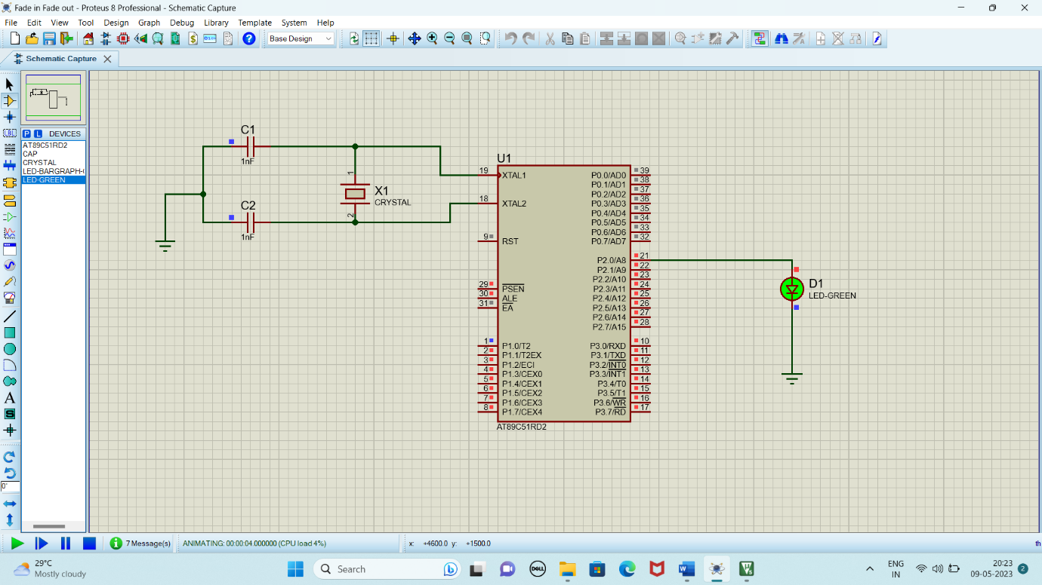

**RESULT:**

Thus the program has been successfully verified and executed.